DEviRank: An Evidence-Weighted Network Proximity Framework for Drug Prioritization in Network-based Drug Repurposing

Seirana Hashemi[1], David Ellinghaus[1]
¹ Institute of Clinical Molecular Biology & University Hospital Schleswig-Holstein (UKSH), Kiel University Rosalind-Franklin-Str. 12, D-24105 Kiel, Germany
Corresponding Author: Seirana Hashemi
s.hashemi@ikmb.uni-kiel.de
- Proximity Measure and Statistical Assessment
Guney. et al.[10] define the network-based distance between a drug and a disease as the average of shortest distances from drug target proteins to the closest disease target protein (d_{asc}) within a protein–protein interaction (PPI) network. Specifically, for each drug target protein, the shortest path to any disease target protein is computed, and these minimal distances are then averaged across all drug targets.
To illustrate this concept, Fig. 1 presents a simple example of a drug–disease association in a PPI network. The drug targets proteins $s_{1}$ and $s_{2}$ , while disease effects proteins $t_{1}$ and $t_{2}$ and $t_{3}$ ​. For each drug target protein, the shortest path to the disease target set $\left\{t_{1},t_{2},t_{3}\right\}$ is identified. In this example, the closest disease target to $s_{1}$ is $t_{2}$, yielding a shortest path length of 2. Similarly, the shortest path from $s_{2}$​ to the disease target set has length 3 targeting $t_{3}$. The d_{asc} between the drug and disease target sets is therefore computed as (2+3)/2=2.5.
This example demonstrates how network proximity is quantified in the Guney et al.[10] framework and forms the basis for assessing whether a drug is closer to disease-associated proteins than expected by chance.
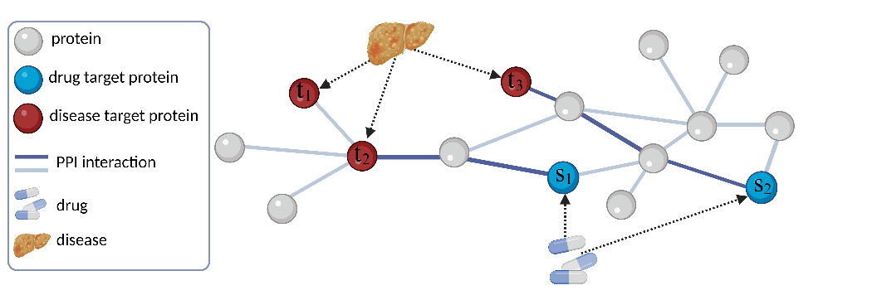
Fig. s1. Illustration of PPI networks and set of disease target proteins t_{1,} t₂ and t₃ and drug target proteins s₁ and s₂.
- Toy Example Illustration.
Fig.s2 illustrates a toy PPI network containing a drug d₁ targeting proteins s₁ and s₂, and a disease characterized by target proteins t₁ and t₂. Disease proteins weights are first computed, followed by weighted path evaluation for drug target protein and final drug score calculation.
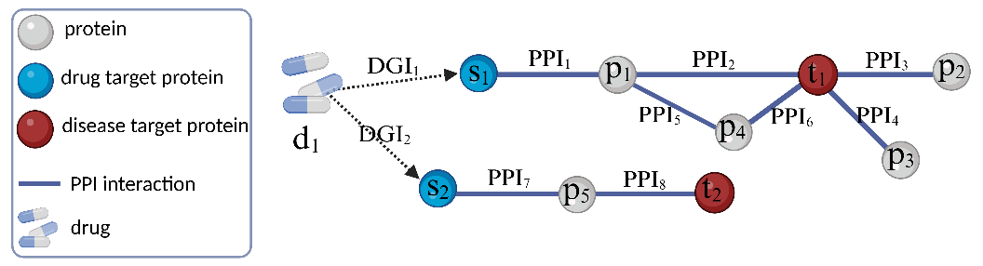
Fig. s2. A toy PPI network with a sample drug d₁ with targeted proteins s₁ and s₂. And a disease sample with target proteins t₁ and t₂.
Step1: Weighting disease target proteins.
$$w_{t}(t_{1})={ppi}_{2}+{ppi}_{3}+{ppi}_{4}+{ppi}_{6}$$
$$w_{t}(t_{2})={ppi}_{8}$$
Step2: Weighting drug target proteins.
$$w_{s}(s_{1})={(ppi}_{1}*{ppi}_{2}+{ppi}_{1}*{ppi}_{5}*{ppi}_{6})*(1+w_{t}(t_{1}))$$
$w_{s}\left(s_{2}\right)=\left({ppi}_{7}*{ppi}_{8}\right)*(1+w_{t}(t_{2})$)
Step3: Computing the Drug Score.
$$w_{d}\left(d_{1}\right)=({dgi}_{1}*w_{s}\left(s_{1}\right)+ {dgi}_{2}*w_{s}\left(s_{2}\right))/2$$
- Step-by-step Time-Complexity Derivation for DEviRank Path Aggregation (L_{max}=3, Shortest Paths)
This note provides a step-by-step derivation of the per-drug time complexity for the DEviRank scoring term that aggregates contributions over shortest paths of bounded length (maximum length L = 3) in a weighted protein–protein interaction (PPI) network.
  - Notation and Assumptions
Let G = (V, E) be the PPI graph with |V| nodes and |E| edges.
Let S be the set of drug target proteins and T the set of disease-associated proteins.
Let Δ denote the maximum node degree in G, and deg(v) the degree of node v.
We enumerate only sample paths (no repeated nodes) with length at most L = 3.
We assume O(1) lookup for membership in T.

We analyze the dominant path-aggregation term used to score a drug d:
$$w_{d}(d)=\sum_{s∈S}{{DGI}_{t}*\left(\sum_{\begin{aligned}tϵT, \\ pϵP\left[s→t\right]\end{aligned}}{\left(\prod_{e∈p}{{PPI}_{e}*\left(1+\sum_{n∈N\left[t\right]}{{PPI}_{n}}\right)}\right)}\right)}$$
where $N[t]$ denotes the set of edges connecting protein t to its neighboring proteins, $P[s→t]$ denotes the set of paths from $s$ to $t$, $e$ represents an edge along path $p$, and ${PPI}_{e}$ is the confidence score of interaction $e$.
The per-path work includes multiplying up to 3 edge weights (PPI_{e)} and a constant number of scalar multiplications/additions. Thus, the cost per enumerated path is O(1) when L is a small constant.
  - Step A: Compute Disease Weights $w_{t}\left(t\right)$
The disease weight for each t ∈ T is:
$$w_{t}\left(t\right)=\sum_{n∈N\left[t\right]}{{PPI}_{n}}$$
Computing $w_{t}\left(t\right)$ for a single t visits all incident edges once, costing O(deg(t)). Therefore, computing all disease weights costs:
$$T_{total-disease-targets}=O(\sum_{t∈T }{deg⁡(t))}$$
  - Step B: Bound the Number of Shortest Paths from a Fixed s (L_{max}=3)
We bound the number of candidate simple paths starting at a fixed drug target node s, for lengths 0, 1, 2, and 3.
Length 0 (zero edge): disease target node t is the drug target s.
$$\#paths_{len0\left(s\right)}=1$$
Length 1 (one edge): the number of neighbors is at most deg(s).
$$\#paths_{len1}(s) ≤ deg(s)$$
Length 2 (two edges): after choosing the first neighbor, the second step can go to at most (Δ − 1) new nodes (we cannot return to s if paths are simple).
$$\#paths_{len2}(s) ≤ deg(s) · (Δ - 1)$$
Length 3 (three edges): similarly, after two steps, the third step has at most (Δ − 1) choices again to avoid revisiting the previous node(s), yielding:
$$\#paths_{len3}(s) ≤ deg(s) ·({Δ-1)}^{2}$$
Thus, the total number of simple paths from s of length at most 3 is bounded by:
$$\#paths_{len≤3}(s) ≤ 1+deg(s) + deg(s)(Δ - 1) + deg(s)({Δ-1)}^{2}$$
$$⇒T_{paths}(s)=O(\deg\left(s\right)Δ^{2})$$

Where $Δ$ denotes the maximum degree of the PPI network.
  - Step C: Total Path Enumeration Cost Over All Drug Targets
Because the work per enumerated path is O(1) for L_{max} = 3, the time to enumerate and score all bounded-length paths originating from s is:
$$T_{paths}(s)=O(\deg\left(s\right)Δ^{2})$$
Summing over all s ∈ S gives the per-drug path aggregation cost:
$$T_{total path from S to T}=O(\sum_{s∈S }{deg⁡(s)Δ^{2})}$$
A simple worst-case bound follows from deg(s) ≤ Δ for all s:
$$T_{total path from S to T}=O\left(\left|S\right|∆^{3}\right) (worst case)$$
  - Final Per-Drug Time Complexity
Computations from steps 2,3 and 4 yields:
$$T_{total}=O(\sum_{t∈T}{\deg\left(t\right)}+ \sum_{s∈S }{deg⁡(s)Δ^{2}})$$
and in the worst case:
$$T_{total}=O\left(\sum_{t∈T}{\deg\left(t\right)}+\left|S\right|∆^{3}\right)$$
  - Notes on Practical Implementation
1) The bound assumes path enumeration is performed from each s and endpoints are checked against T in O(1).
2) Restricting to shortest paths avoids repeated-node walks, which would otherwise increase path counts.
3) Since drugs are independent, total runtime scales linearly with the number of drugs and is embarrassingly parallel across drugs.

  - Algorithm 1. Pseudocode of the DEviRank drug prioritization framework
Input:
G = (V, E) // PPI network with edge weights PPI_e
T ⊆ V // Disease target proteins
S ⊆ V // Drug target proteins
DGI(s) // Drug–gene interaction score for each s ∈ S
N // Number of target genes per drug

Output:
w_d(d) // Final drug score

// Step 1: Disease protein weights
for each t ∈ T do
w_t(t) ← sum of PPI weights of edges incident to t
end for

// Step 2: Drug target protein weights
for each s ∈ S do
w_s(s) ← 0
for each t ∈ T do
for each path p ∈ P[s → t] do
path_score ← product of PPI weights along p
w_s(s) ← w_s(s) + path_score × (1 + w_t(t))
end for
end for
end for

// Step 3: Final drug score
w_d(d) ← 0
for each s ∈ S do
w_d(d) ← w_d(d) + DGI(s) × w_s(s)
end for
w_d(d) ← w_d(d)/n(d) // n(d) ∈ N do
return w_d(d)

